

unfold_lessHide code

In [1]:

linkcode

import numpy as np

import pandas as pd

import matplotlib.pyplot as plt

import seaborn as sns

import plotly.express as px

import plotly.graph_objects as go

from plotly.subplots import make_subplots

from sklearn.linear_model import LogisticRegression

from sklearn.model_selection import train_test_split

from sklearn.metrics import confusion_matrix, f1_score, accuracy_score, classification_report

from sklearn.preprocessing import StandardScaler

from sklearn.model_selection import GridSearchCV

from sklearn.pipeline import Pipeline

import os

for dirname, _, filenames **in** os.walk('/kaggle/input'):

for filename **in** filenames:

print(os.path.join(dirname, filename))

/kaggle/input/d/toomuchsauce/imagebrain/Untitled design.png

/kaggle/input/mental-health-in-tech-survey/survey.csv

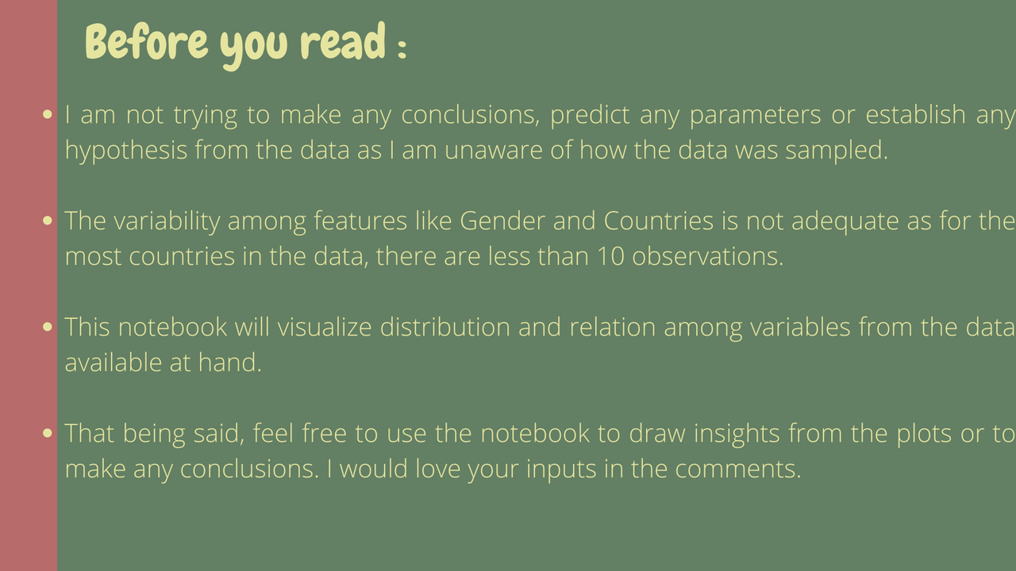

About the Data

| Column | Description |
| --- | --- |
| Timestamp | Timestamp |
| Age | Age |
| Gender | Gender |
| Country | Country |
| state | If you live in the United States, which state or territory do you live in? |
| self_employed | Are you self-employed? |
| family_history | Do you have a family history of mental illness? |
| treatment | Have you sought treatment for a mental health condition? |
| work_interfere | If you have a mental health condition, do you feel that it interferes with your work? |
| no_employees | How many employees does your company or organization have? |
| remote_work | Do you work remotely (outside of an office) at least 50% of the time? |
| tech_company | Is your employer primarily a tech company/organization? |
| benefits | Does your employer provide mental health benefits? |
| care_options | Do you know the options for mental health care your employer provides? |
| wellness_program | Has your employer ever discussed mental health as part of an employee wellness program? |
| seek_help | Does your employer provide resources to learn more about mental health issues and how to seek help? |
| anonymity | Is your anonymity protected if you choose to take advantage of mental health or substance abuse treatment resources? |
| leave | How easy is it for you to take medical leave for a mental health condition? |
| mentalhealthconsequence | Do you think that discussing a mental health issue with your employer would have negative consequences? |
| physhealthconsequence | Do you think that discussing a physical health issue with your employer would have negative consequences? |
| coworkers | Would you be willing to discuss a mental health issue with your coworkers? |
| supervisor | Would you be willing to discuss a mental health issue with your direct supervisor(s)? |
| mentalhealthinterview | Would you bring up a mental health issue with a potential employer in an interview? |
| physhealthinterview | Would you bring up a physical health issue with a potential employer in an interview? |
| mentalvsphysical | Do you feel that your employer takes mental health as seriously as physical health? |
| obs_consequence | Have you heard of or observed negative consequences for coworkers with mental health conditions in your workplace? |
| comments | Any additional notes or comments |

In [2]:

data = pd.read_csv('/kaggle/input/mental-health-in-tech-survey/survey.csv')

data.head(10).style.applymap(lambda x : "background-color: #eaedb4")

Out[2]:

|  | Timestamp | Age | Gender | Country | state | self_employed | family_history | treatment | work_interfere | no_employees | remote_work | tech_company | benefits | care_options | wellness_program | seek_help | anonymity | leave | mental_health_consequence | phys_health_consequence | coworkers | supervisor | mental_health_interview | phys_health_interview | mental_vs_physical | obs_consequence | comments |
| --- | --- | --- | --- | --- | --- | --- | --- | --- | --- | --- | --- | --- | --- | --- | --- | --- | --- | --- | --- | --- | --- | --- | --- | --- | --- | --- | --- |
| 0 | 2014-08-27 11:29:31 | 37 | Female | United States | IL | nan | No | Yes | Often | 6-25 | No | Yes | Yes | Not sure | No | Yes | Yes | Somewhat easy | No | No | Some of them | Yes | No | Maybe | Yes | No | nan |
| 1 | 2014-08-27 11:29:37 | 44 | M | United States | IN | nan | No | No | Rarely | More than 1000 | No | No | Don't know | No | Don't know | Don't know | Don't know | Don't know | Maybe | No | No | No | No | No | Don't know | No | nan |
| 2 | 2014-08-27 11:29:44 | 32 | Male | Canada | nan | nan | No | No | Rarely | 6-25 | No | Yes | No | No | No | No | Don't know | Somewhat difficult | No | No | Yes | Yes | Yes | Yes | No | No | nan |
| 3 | 2014-08-27 11:29:46 | 31 | Male | United Kingdom | nan | nan | Yes | Yes | Often | 26-100 | No | Yes | No | Yes | No | No | No | Somewhat difficult | Yes | Yes | Some of them | No | Maybe | Maybe | No | Yes | nan |
| 4 | 2014-08-27 11:30:22 | 31 | Male | United States | TX | nan | No | No | Never | 100-500 | Yes | Yes | Yes | No | Don't know | Don't know | Don't know | Don't know | No | No | Some of them | Yes | Yes | Yes | Don't know | No | nan |
| 5 | 2014-08-27 11:31:22 | 33 | Male | United States | TN | nan | Yes | No | Sometimes | 6-25 | No | Yes | Yes | Not sure | No | Don't know | Don't know | Don't know | No | No | Yes | Yes | No | Maybe | Don't know | No | nan |
| 6 | 2014-08-27 11:31:50 | 35 | Female | United States | MI | nan | Yes | Yes | Sometimes | 1-5 | Yes | Yes | No | No | No | No | No | Somewhat difficult | Maybe | Maybe | Some of them | No | No | No | Don't know | No | nan |
| 7 | 2014-08-27 11:32:05 | 39 | M | Canada | nan | nan | No | No | Never | 1-5 | Yes | Yes | No | Yes | No | No | Yes | Don't know | No | No | No | No | No | No | No | No | nan |
| 8 | 2014-08-27 11:32:39 | 42 | Female | United States | IL | nan | Yes | Yes | Sometimes | 100-500 | No | Yes | Yes | Yes | No | No | No | Very difficult | Maybe | No | Yes | Yes | No | Maybe | No | No | nan |
| 9 | 2014-08-27 11:32:43 | 23 | Male | Canada | nan | nan | No | No | Never | 26-100 | No | Yes | Don't know | No | Don't know | Don't know | Don't know | Don't know | No | No | Yes | Yes | Maybe | Maybe | Yes | No | nan |

In [3]:

def EDA(df):

print('**\033**[1m' +'EXPLORATORY DATA ANALYSIS :'+ '**\033**[0m**\n**')

print('**\033**[1m' + 'Shape of the data (rows, columns):' + '**\033**[0m')

print(df.shape,

'**\n**------------------------------------------------------------------------------------**\n**')

print('**\033**[1m' + 'All columns from the dataframe :' + '**\033**[0m')

print(df.columns,

'**\n**------------------------------------------------------------------------------------**\n**')

print('**\033**[1m' + 'Datatpes and Missing values:' + '**\033**[0m')

print(df.info(),

'**\n**------------------------------------------------------------------------------------**\n**')

for col **in** df.columns:

print('**\033**[1m' + 'Unique values in **{}** :'.format(col) + '**\033**[0m',len(data[col].unique()))

print('**\n**------------------------------------------------------------------------------------**\n**')

print('**\033**[1m' + 'Summary statistics for the data :' + '**\033**[0m')

print(df.describe(include='all'),

'**\n**------------------------------------------------------------------------------------**\n**')

print('**\033**[1m' + 'Memory used by the data :' + '**\033**[0m')

print(df.memory_usage(),

'**\n**------------------------------------------------------------------------------------**\n**')

print('**\033**[1m' + 'Number of duplicate values :' + '**\033**[0m')

print(df.duplicated().sum())

EDA(data)

**EXPLORATORY DATA ANALYSIS :**

**Shape of the data (rows, columns):**

(1259, 27)

------------------------------------------------------------------------------------

**All columns from the dataframe :**

Index(['Timestamp', 'Age', 'Gender', 'Country', 'state', 'self_employed',

'family_history', 'treatment', 'work_interfere', 'no_employees',

'remote_work', 'tech_company', 'benefits', 'care_options',

'wellness_program', 'seek_help', 'anonymity', 'leave',

'mental_health_consequence', 'phys_health_consequence', 'coworkers',

'supervisor', 'mental_health_interview', 'phys_health_interview',

'mental_vs_physical', 'obs_consequence', 'comments'],

dtype='object')

------------------------------------------------------------------------------------

**Datatpes and Missing values:**

<class 'pandas.core.frame.DataFrame'>

RangeIndex: 1259 entries, 0 to 1258

Data columns (total 27 columns):

# Column Non-Null Count Dtype

--- ------ -------------- -----

0 Timestamp 1259 non-null object

1 Age 1259 non-null int64

2 Gender 1259 non-null object

3 Country 1259 non-null object

4 state 744 non-null object

5 self_employed 1241 non-null object

6 family_history 1259 non-null object

7 treatment 1259 non-null object

8 work_interfere 995 non-null object

9 no_employees 1259 non-null object

10 remote_work 1259 non-null object

11 tech_company 1259 non-null object

12 benefits 1259 non-null object

13 care_options 1259 non-null object

14 wellness_program 1259 non-null object

15 seek_help 1259 non-null object

16 anonymity 1259 non-null object

17 leave 1259 non-null object

18 mental_health_consequence 1259 non-null object

19 phys_health_consequence 1259 non-null object

20 coworkers 1259 non-null object

21 supervisor 1259 non-null object

22 mental_health_interview 1259 non-null object

23 phys_health_interview 1259 non-null object

24 mental_vs_physical 1259 non-null object

25 obs_consequence 1259 non-null object

26 comments 164 non-null object

dtypes: int64(1), object(26)

memory usage: 265.7+ KB

None

------------------------------------------------------------------------------------

**Unique values in Timestamp :** 1246

**Unique values in Age :** 53

**Unique values in Gender :** 49

**Unique values in Country :** 48

**Unique values in state :** 46

**Unique values in self_employed :** 3

**Unique values in family_history :** 2

**Unique values in treatment :** 2

**Unique values in work_interfere :** 5

**Unique values in no_employees :** 6

**Unique values in remote_work :** 2

**Unique values in tech_company :** 2

**Unique values in benefits :** 3

**Unique values in care_options :** 3

**Unique values in wellness_program :** 3

**Unique values in seek_help :** 3

**Unique values in anonymity :** 3

**Unique values in leave :** 5

**Unique values in mental_health_consequence :** 3

**Unique values in phys_health_consequence :** 3

**Unique values in coworkers :** 3

**Unique values in supervisor :** 3

**Unique values in mental_health_interview :** 3

**Unique values in phys_health_interview :** 3

**Unique values in mental_vs_physical :** 3

**Unique values in obs_consequence :** 2

**Unique values in comments :** 161

------------------------------------------------------------------------------------

**Summary statistics for the data :**

Timestamp Age Gender Country state \

count 1259 1.259000e+03 1259 1259 744

unique 1246 NaN 49 48 45

top 2014-08-27 12:44:51 NaN Male United States CA

freq 2 NaN 615 751 138

mean NaN 7.942815e+07 NaN NaN NaN

std NaN 2.818299e+09 NaN NaN NaN

min NaN -1.726000e+03 NaN NaN NaN

25% NaN 2.700000e+01 NaN NaN NaN

50% NaN 3.100000e+01 NaN NaN NaN

75% NaN 3.600000e+01 NaN NaN NaN

max NaN 1.000000e+11 NaN NaN NaN

self_employed family_history treatment work_interfere no_employees \

count 1241 1259 1259 995 1259

unique 2 2 2 4 6

top No No Yes Sometimes 6-25

freq 1095 767 637 465 290

mean NaN NaN NaN NaN NaN

std NaN NaN NaN NaN NaN

min NaN NaN NaN NaN NaN

25% NaN NaN NaN NaN NaN

50% NaN NaN NaN NaN NaN

75% NaN NaN NaN NaN NaN

max NaN NaN NaN NaN NaN

... leave mental_health_consequence phys_health_consequence \

count ... 1259 1259 1259

unique ... 5 3 3

top ... Don't know No No

freq ... 563 490 925

mean ... NaN NaN NaN

std ... NaN NaN NaN

min ... NaN NaN NaN

25% ... NaN NaN NaN

50% ... NaN NaN NaN

75% ... NaN NaN NaN

max ... NaN NaN NaN

coworkers supervisor mental_health_interview phys_health_interview \

count 1259 1259 1259 1259

unique 3 3 3 3

top Some of them Yes No Maybe

freq 774 516 1008 557

mean NaN NaN NaN NaN

std NaN NaN NaN NaN

min NaN NaN NaN NaN

25% NaN NaN NaN NaN

50% NaN NaN NaN NaN

75% NaN NaN NaN NaN

max NaN NaN NaN NaN

mental_vs_physical obs_consequence comments

count 1259 1259 164

unique 3 2 160

top Don't know No * Small family business - YMMV.

freq 576 1075 5

mean NaN NaN NaN

std NaN NaN NaN

min NaN NaN NaN

25% NaN NaN NaN

50% NaN NaN NaN

75% NaN NaN NaN

max NaN NaN NaN

[11 rows x 27 columns]

------------------------------------------------------------------------------------

**Memory used by the data :**

Index 128

Timestamp 10072

Age 10072

Gender 10072

Country 10072

state 10072

self_employed 10072

family_history 10072

treatment 10072

work_interfere 10072

no_employees 10072

remote_work 10072

tech_company 10072

benefits 10072

care_options 10072

wellness_program 10072

seek_help 10072

anonymity 10072

leave 10072

mental_health_consequence 10072

phys_health_consequence 10072

coworkers 10072

supervisor 10072

mental_health_interview 10072

phys_health_interview 10072

mental_vs_physical 10072

obs_consequence 10072

comments 10072

dtype: int64

------------------------------------------------------------------------------------

**Number of duplicate values :**

0

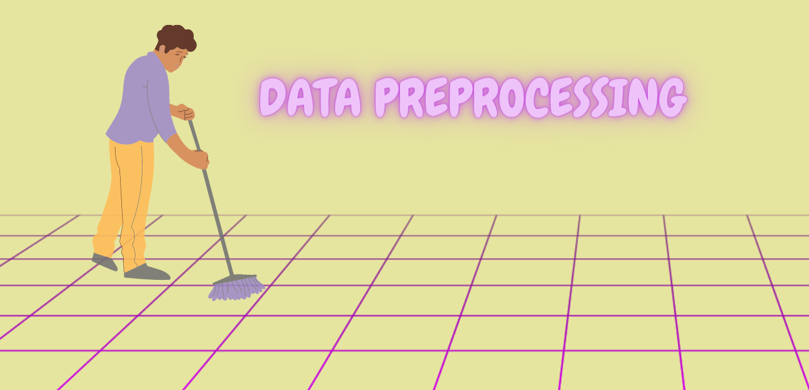

unfold_lessHide code

In [4]:

plt.figure(figsize=(12,6) , dpi=100)

sns.heatmap(data.isna(), cmap='YlGn', cbar = False, alpha = 0.6)

plt.xticks(rotation=90)

hfont = {'fontname':'monospace'}

plt.title ('Heatmap For missing values',

**hfont,

color = '#29452b',

weight = 'semibold',

fontsize = 16,

alpha = 0.6)

plt.xticks(**hfont)

plt.show()

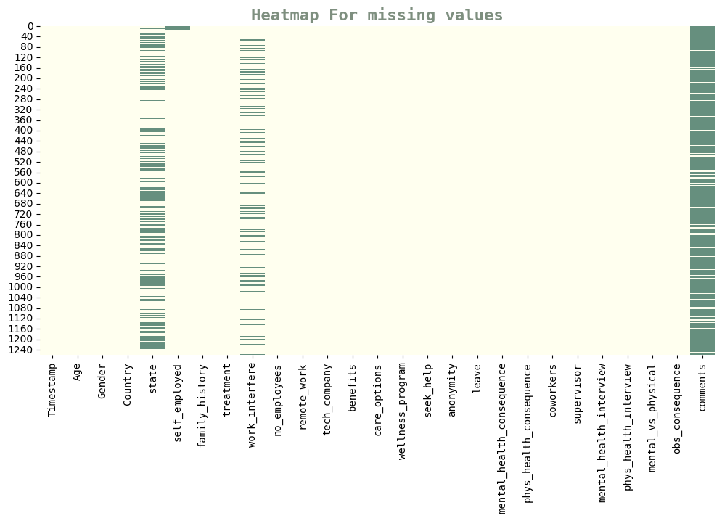

unfold_lessHide code

In [5]:

cols = []

props = []

prop = {'Column' : cols, 'Missing_Proportion': props}

for col **in** data.columns:

missing_prop = data[col].isna().sum() / data.shape[0] * 100

if missing_prop > 0:

cols.append(col)

props.append(missing_prop)

prop = pd.DataFrame(prop).sort_values('Missing_Proportion', ignore_index=True)

prop.style.applymap(lambda x : "background-color: #eaedb4")

Out[5]:

|  | Column | Missing_Proportion |
| --- | --- | --- |
| 0 | self_employed | 1.429706 |
| 1 | work_interfere | 20.969023 |
| 2 | state | 40.905481 |
| 3 | comments | 86.973789 |

In [6]:

print('**\033**[1m' + 'Total countries surveyed :' + '**\033**[0m', len(data.Country.value_counts()))

print('**\033**[1m' + 'Unique states in the Data :' + '**\033**[0m**\n**', data.state.unique())

**Total countries surveyed :** 48

**Unique states in the Data :**

['IL' 'IN' nan 'TX' 'TN' 'MI' 'OH' 'CA' 'CT' 'MD' 'NY' 'NC' 'MA' 'IA' 'PA'

'WA' 'WI' 'UT' 'NM' 'OR' 'FL' 'MN' 'MO' 'AZ' 'CO' 'GA' 'DC' 'NE' 'WV'

'OK' 'KS' 'VA' 'NH' 'KY' 'AL' 'NV' 'NJ' 'SC' 'VT' 'SD' 'ID' 'MS' 'RI'

'WY' 'LA' 'ME']

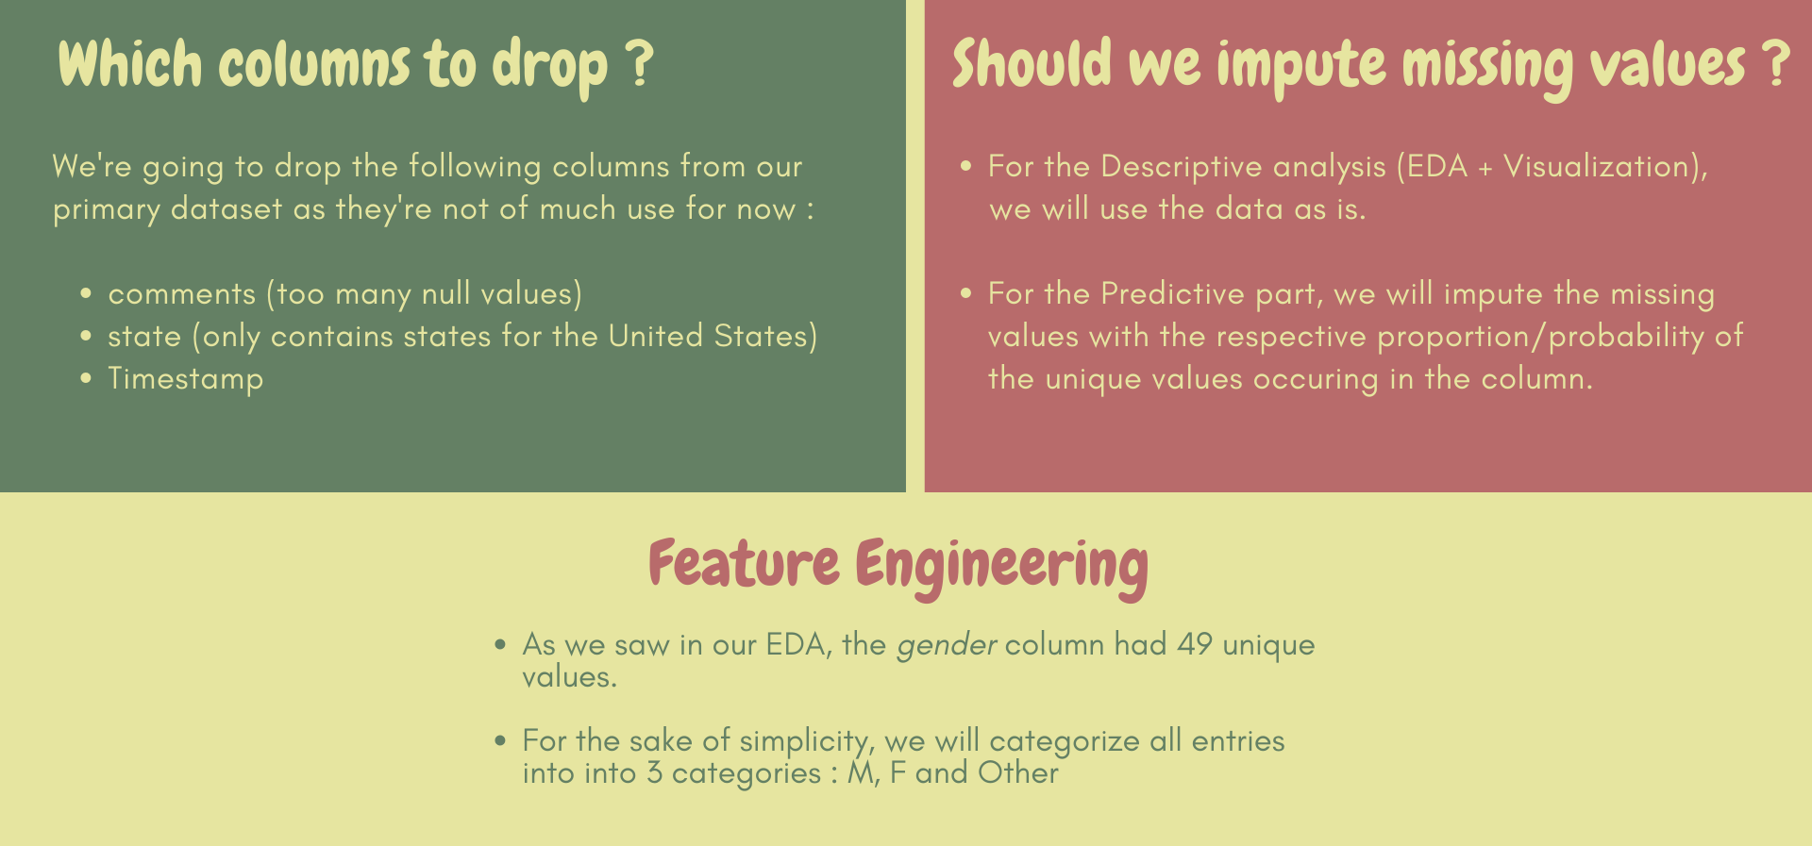

In [7]:

*# Dropping*

df = data.drop(columns=['state', 'comments', 'Timestamp'])

print('**\033**[1m' + 'Columns in updated Dataframe :' + '**\033**[0m', len(df.columns))

**Columns in updated Dataframe :** 24

In [8]:

*# Imputing*

df['self_employed'] = df['self_employed']\

.fillna(pd.Series(np.random.choice(['Yes', 'No'], p=[0.117647, 0.882353], size=len(df))))

df['work_interfere'] = df['work_interfere']\

.fillna(pd.Series(np.random.choice(['Sometimes', 'Never', 'Rarely', 'Often']

, p=[0.467337, 0.214070, 0.173869, 0.144724], size=len(df))))

print('**\033**[1m' + 'Total empty values in the Dataset :' + '**\033**[0m' , df.isnull().sum().sum())

**Total empty values in the Dataset :** 0

In [9]:

*# Feature engineering*

age = []

for i **in** data.Age:

if (i<18) **or** (i>99):

age.append(31) *# Median*

else:

age.append(i)

df['Age'] = age

other = ['A little about you', 'p', 'Nah', 'Enby', 'Trans-female','something kinda male?','queer/she/they','non-binary','All','fluid', 'Genderqueer','Androgyne', 'Agender','Guy (-ish) ^_^', 'male leaning androgynous','Trans woman','Neuter', 'Female (trans)','queer','ostensibly male, unsure what that really means','trans']

male = ['male', 'Male','M', 'm', 'Male-ish', 'maile','Cis Male','Mal', 'Male (CIS)','Make','Male ', 'Man', 'msle','cis male', 'Cis Man','Malr','Mail']

female = ['Female', 'female','Cis Female', 'F','f','Femake', 'woman','Female ','cis-female/femme','Female (cis)','femail','Woman','female']

df['Gender'].replace(to_replace = other, value = 'other', inplace=True)

df['Gender'].replace(to_replace = male, value = 'M', inplace=True)

df['Gender'].replace(to_replace = female, value = 'F', inplace=True)

print('**\033**[1m' + 'Unique values in updated Gender column :' + '**\033**[0m', df.Gender.unique())

print('**\033**[1m' + 'Range of column Age (Before) :' + '**\033**[0m', (data.Age.min(), data.Age.max()))

print('**\033**[1m' + 'Range of column Age :' + '**\033**[0m', (df.Age.min(), df.Age.max()))

**Unique values in updated Gender column :** ['F' 'M' 'other']

**Range of column Age (Before) :** (-1726, 99999999999)

**Range of column Age :** (18, 72)



unfold_lessHide code

In [10]:

*# Univariate visualization of categorical variables*

df_ = df.drop(['Age', 'Country'], axis=1)

buttons = []

i = 0

vis = [False] * 24

for col **in** df_.columns:

vis[i] = True

buttons.append({'label' : col,

'method' : 'update',

'args' : [{'visible' : vis},

{'title' : col}] })

i+=1

vis = [False] * 24

fig = go.Figure()

for col **in** df_.columns:

fig.add_trace(go.Pie(

values = df_[col].value_counts(),

labels = df_[col].value_counts().index,

title = dict(text = 'Distribution of **{}**'.format(col),

font = dict(size=18, family = 'monospace'),

),

hole = 0.5,

hoverinfo='label+percent',))

fig.update_traces(hoverinfo='label+percent',

textinfo='label+percent',

textfont_size=12,

opacity = 0.8,

showlegend = False,

marker = dict(colors = sns.color_palette('YlGn').as_hex(),

line=dict(color='#000000', width=1)))

fig.update_layout(margin=dict(t=0, b=0, l=0, r=0),

updatemenus = [dict(

type = 'dropdown',

x = 1.15,

y = 0.85,

showactive = True,

active = 0,

buttons = buttons)],

annotations=[

dict(text = "<b>Choose<br>Column<b> : ",

showarrow=False,

x = 1.06, y = 0.92, yref = "paper", align = "left")])

for i **in** range(1,22):

fig.data[i].visible = False

fig.show()

M78.7%F19.6%other1.67%Distribution of Gender

ChooseColumn : Gender▼

unfold_lessHide code

In [11]:

*# Univariate visualization of non-categorical variables*

fig = make_subplots(rows = 2, cols=1)

fig.append_trace(go.Bar(

y = data['Country'].value_counts(),

x = data['Country'].value_counts().index,

name = 'Observations from Countries (Log)',

text = data['Country'].value_counts(),

textfont = dict(size = 10,

family = 'monospace'),

textposition = 'outside',

marker=dict(color="#6aa87b")

), row=1, col=1)

fig.append_trace(go.Histogram(

x = df['Age'],

nbinsx = 8,

text = ['16', '500', '562', '149', '26', '5', '1'],

marker = dict(color="#6aa87b")),

row=2, col=1)

*# For Subplot : 1*

fig.update_xaxes(

row=1, col=1,

tickfont = dict(size=10, family = 'monospace'),

tickmode = 'array',

ticktext = data['Country'].value_counts().index,

tickangle = 60,

ticklen = 6,

showline = False,

showgrid = False,

ticks = 'outside')

fig.update_yaxes(type = 'log',

row=1, col=1,

tickfont = dict(size=15, family = 'monospace'),

tickmode = 'array',

showline = False,

showgrid = False,

ticks = 'outside')

fig.update_traces(

marker_line_color='black',

marker_line_width= 1.2,

opacity=0.6,

row = 1, col = 1)

fig.update_xaxes(range=[-1,48], row = 1, col = 1)

*# For Subplot : 2*

fig.update_xaxes(

title = dict(text = 'Age',

font = dict(size = 15,

family = 'monospace')),

row=2, col=1,

tickfont = dict(size=15, family = 'monospace', color = 'black'),

tickmode = 'array',

ticktext = ['10-19', '20-29', '30-39', '40-49', '50-59', '60-69', '70-79'],

ticklen = 6,

showline = False,

showgrid = False,

ticks = 'outside')

fig.update_yaxes(

row=2, col=1,

tickfont = dict(size=15, family = 'monospace'),

tickmode = 'array',

showline = False,

showgrid = False,

ticks = 'outside')

fig.update_traces(

marker_line_color='black',

marker_line_width = 2,

opacity = 0.6,

row = 2, col = 1)

fig.update_layout(height=1200, width=900,

title = dict(text = 'Univariate visualization of non-categorical variables<br>1. Observation from Countries(Log)<br>2. Ages Count',

x = 0.5,

font = dict(size = 16, color ='#27302a',

family = 'monospace')),

plot_bgcolor='#edf2c7',

paper_bgcolor = '#edf2c7',

showlegend = False)

fig.show()

75118572452727211310877776665443333222221111111111111111111United StatesUnited KingdomCanadaGermanyIrelandNetherlandsAustraliaFranceIndiaNew ZealandPolandSwitzerlandSwedenItalySouth AfricaBelgiumBrazilIsraelSingaporeBulgariaAustriaFinlandMexicoRussiaDenmarkGreeceColombiaCroatiaPortugalMoldovaGeorgiaBahamas, TheChinaThailandCzech RepublicNorwayRomaniaNigeriaJapanHungaryBosnia and HerzegovinaUruguaySpainZimbabweLatviaCosta RicaSloveniaPhilippines1251025100251000165005621492651102030405060700100200300400500

Univariate visualization of non-categorical variables1. Observation from Countries(Log)2. Ages CountAge

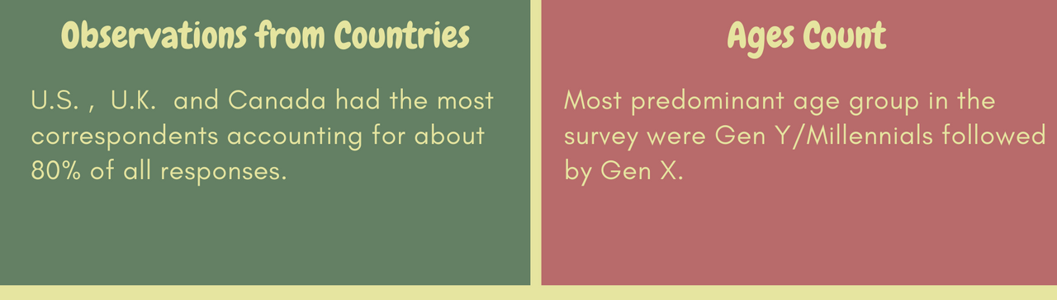



unfold_lessHide code

In [12]:

prop = pd.DataFrame(df.Gender.value_counts(normalize=True))

prop.style.applymap(lambda x : "background-color: #eaedb4")

Out[12]:

|  | Gender |
| --- | --- |
| M | 0.787133 |
| F | 0.196187 |
| other | 0.016680 |

unfold_lessHide code

In [13]:

male_country = df[df['Gender'] == 'M'][['Country', 'Gender']]

female_country = df[df['Gender'] == 'F'][['Country', 'Gender']]

male_country = male_country.value_counts()

female_country = female_country.value_counts()

male_country = pd.DataFrame(male_country).reset_index().rename(columns={0:'count'}).head(15)

female_country = pd.DataFrame(female_country).reset_index().rename(columns={0:'count'}).head(15)

male_country['count'] = male_country['count'] * -1

unfold_lessHide code

In [14]:

fig = make_subplots(rows=1, cols=2,

specs=[[{}, {}]],

shared_yaxes=True,

horizontal_spacing=0)

fig.append_trace(go.Bar(

y = male_country.Country,

x = male_country['count'],

text = male_country['count'],

textfont = dict(size = 10, color = '#6aa87b'),

textposition = 'outside',

name = 'Male responses',

marker_color='#6aa87b',

orientation = 'h'),

row=1, col=1)

fig.append_trace(go.Bar(

y = male_country.Country,

x = female_country['count'],

text = female_country['count'],

textfont = dict(size = 10, color = '#913f3f'),

textposition = 'outside',

name = 'Female responses',

marker_color='#913f3f',

orientation = 'h'),

row=1, col=2)

fig.update_xaxes(

tickfont = dict(size=15),

tickmode = 'array',

ticklen = 6,

showline = False,

showgrid = False,

ticks = 'outside')

fig.update_yaxes(showgrid=False,

categoryorder='total ascending',

ticksuffix=' ',

showline=False)

fig.update_layout(

font_family = 'monospace',

title = dict(text = 'Gender of the survey respondents across Countries', x = 0.525),

margin = dict(t=80, b=0, l=70, r=40),

hovermode = "y unified",

plot_bgcolor = '#edf2c7',

paper_bgcolor = '#edf2c7',

font = dict(color='black'),

legend = dict(orientation="h",

yanchor="bottom", y=1,

xanchor="center", x=0.5),

hoverlabel = dict(bgcolor="#edf2c7", font_size=13,

font_family="Monospace"))

fig.show()

-562-154-56-42-24-23-16-13-8-7-7-6-6-6-5−400−2000New Zealand Italy Brazil Poland Switzerland South Africa Australia France India Ireland Netherlands Germany Canada United Kingdom United States 1802614543222111111050100150

Male responsesFemale responsesGender of the survey respondents across Countries

unfold_lessHide code

In [15]:

male = df[df.Gender == 'M'].drop(['Gender', 'Age', 'Country'], axis=1)

female = df[df.Gender == 'F'].drop(['Gender', 'Age', 'Country'], axis=1)

other = df[df.Gender == 'other'].drop(['Gender', 'Age', 'Country'], axis=1)

unfold_lessHide code

In [16]:

buttons = []

i = 0

vis = [False] * 21

for col **in** male.columns:

vis[i] = True

buttons.append({'label' : col,

'method' : 'update',

'args' : [{'visible' : vis},

{'title' : col}] })

i+=1

vis = [False] * 21

fig = make_subplots(rows=1, cols=2,

specs=[[{'type':'domain'}, {'type':'domain'}]])

for col **in** male.columns:

fig.add_trace(go.Pie(

values = male[col].value_counts(),

labels = male[col].value_counts().index,

title = dict(text = 'Male distribution<br>of **{}**'.format(col),

font = dict(size=18, family = 'monospace'),

),

hole = 0.5,

hoverinfo='label+percent',),1,1)

for col **in** female.columns:

fig.add_trace(go.Pie(

values = female[col].value_counts(),

labels = female[col].value_counts().index,

title = dict(text = 'Female distribution<br>of **{}**'.format(col),

font = dict(size=18, family = 'monospace'),

),

hole = 0.5,

hoverinfo='label+percent',),1,2)

fig.update_traces(hoverinfo='label+percent',

textinfo='label+percent',

textfont_size=12,

opacity = 0.8,

showlegend = False,

marker = dict(colors = sns.color_palette('YlGn').as_hex(),

line=dict(color='#000000', width=1)))

fig.update_traces(row=1, col=2, hoverinfo='label+percent',

textinfo='label+percent',

textfont_size=12,

opacity = 0.8,

showlegend = False,

marker = dict(colors = sns.color_palette('Reds').as_hex(),

line=dict(color='#000000', width=1)))

fig.update_layout(margin=dict(t=0, b=0, l=0, r=0),

font_family = 'monospace',

updatemenus = [dict(

type = 'dropdown',

x = 0.62,

y = 0.91,

showactive = True,

active = 0,

buttons = buttons)],

annotations=[

dict(text = "<b>Choose<br>Column<b> : ",

font = dict(size = 14),

showarrow=False,

x = 0.5, y = 1, yref = "paper", align = "left")])

for i **in** range(1,42):

fig.data[i].visible = False

fig.data[21].visible = True

fig.show()

No87.7%Yes12.3%Male distributionof self_employedNo91.1%Yes8.91%Female distributionof self_employed

ChooseColumn : self_employed▼



unfold_lessHide code

In [17]:

*# Choosing countries with more than 30 observations*

us = df[df.Country == 'United States'].drop(['Age', 'Country'], axis=1)

uk = df[df.Country == 'United Kingdom'].drop(['Age', 'Country'], axis=1)

cd = df[df.Country == 'Canada'].drop(['Age', 'Country'], axis=1)

gr = df[df.Country == 'Germany'].drop(['Age', 'Country'], axis=1)

unfold_lessHide code

In [18]:

buttons = []

i = 0

vis = [False] * 22

for col **in** us.columns:

vis[i] = True

buttons.append({'label' : col,

'method' : 'update',

'args' : [{'visible' : vis},

{'title' : col}] })

i+=1

vis = [False] * 22

fig = make_subplots(rows=2, cols=2,

specs=[[{'type':'domain'}, {'type':'domain'}], [{'type':'domain'}, {'type':'domain'}]],

vertical_spacing = 0.1)

for col **in** us.columns:

fig.add_trace(go.Pie(

values = us[col].value_counts(),

labels = us[col].value_counts().index,

title = dict(text = 'U.S. distribution<br>of **{}**'.format(col),

font = dict(size=18, family = 'monospace'),

),

hole = 0.5,

hoverinfo='label+percent',),1,1)

for col **in** uk.columns:

fig.add_trace(go.Pie(

values = uk[col].value_counts(),

labels = uk[col].value_counts().index,

title = dict(text = 'U.K. distribution<br>of **{}**'.format(col),

font = dict(size=18, family = 'monospace'),

),

hole = 0.5,

hoverinfo='label+percent',),1,2)

for col **in** cd.columns:

fig.add_trace(go.Pie(

values = cd[col].value_counts(),

labels = cd[col].value_counts().index,

title = dict(text = 'Canada distribution<br>of **{}**'.format(col),

font = dict(size=18, family = 'monospace'),

),

hole = 0.5,

hoverinfo='label+percent',),2,1)

for col **in** gr.columns:

fig.add_trace(go.Pie(

values = gr[col].value_counts(),

labels = gr[col].value_counts().index,

title = dict(text = 'Germany distribution<br>of **{}**'.format(col),

font = dict(size=18, family = 'monospace'),

),

hole = 0.5,

hoverinfo='label+percent',),2,2)

fig.update_traces(hoverinfo='label+percent',

textinfo='label+percent',

textfont_size=12,

opacity = 0.8,

showlegend = False,

marker = dict(colors = sns.color_palette('RdBu_r').as_hex(),

line=dict(color='#000000', width=1)))

fig.update_traces(row=2, col=1, hoverinfo='label+percent',

textinfo='label+percent',

textfont_size=12,

opacity = 0.8,

showlegend = False,

marker = dict(colors = sns.color_palette('Reds').as_hex(),

line=dict(color='#000000', width=1)))

fig.update_traces(row=2, col=2, hoverinfo='label+percent',

textinfo='label+percent',

textfont_size=12,

opacity = 0.8,

showlegend = False,

marker = dict(colors = sns.color_palette('Reds').as_hex(),

line=dict(color='#000000', width=1)))

fig.update_layout(margin=dict(t=0, b=0, l=0, r=0),

paper_bgcolor = '#edf2c7',

height = 1200,

font_family = 'monospace',

updatemenus = [dict(

type = 'dropdown',

x = 0.60,

y = 0.96,

showactive = True,

active = 0,

buttons = buttons)],

annotations=[

dict(text = "<b>Choose<br>Column<b> : ",

font = dict(size = 14),

showarrow=False,

x = 0.48, y = 1, yref = "paper", align = "left")])

for i **in** range(0,88):

fig.data[i].visible = False

fig.data[0].visible = True

fig.data[22].visible = True

fig.data[44].visible = True

fig.data[66].visible = True

fig.show()

M74.8%F24%other1.2%U.S. distributionof GenderM83.2%F14.1%other2.7%U.K. distributionof GenderM77.8%F19.4%other2.78%Canada distributionof GenderM93.3%other4.44%F2.22%Germany distributionof Gender

ChooseColumn : Gender▼



unfold_lessHide code

In [19]:

seek = df[df.treatment == 'Yes'].drop(['treatment', 'Country', 'Age'], axis=1)

dont = df[df.treatment == 'No'].drop(['treatment', 'Country', 'Age'], axis=1)

unfold_lessHide code

In [20]:

buttons = []

i = 0

vis = [False] * 21

for col **in** seek.columns:

vis[i] = True

buttons.append({'label' : col,

'method' : 'update',

'args' : [{'visible' : vis},

{'title' : col}] })

i+=1

vis = [False] * 21

fig = make_subplots(rows=1, cols=2,

specs=[[{'type':'domain'}, {'type':'domain'}]])

for col **in** dont.columns:

fig.add_trace(go.Pie(

values = dont[col].value_counts(),

labels = dont[col].value_counts().index,

title = dict(text = 'No Treatment: <br>Distribution<br>of **{}**'.format(col),

font = dict(size=18, family = 'monospace'),

),

hole = 0.5,

hoverinfo='label+percent',),1,1)

for col **in** seek.columns:

fig.add_trace(go.Pie(

values = seek[col].value_counts(),

labels = seek[col].value_counts().index,

title = dict(text = 'Seek Treatment: <br>Distribution<br>of **{}**'.format(col),

font = dict(size=18, family = 'monospace'),

),

hole = 0.5,

hoverinfo='label+percent',),1,2)

fig.update_traces(hoverinfo='label+percent',

textinfo='label+percent',

textfont_size=12,

opacity = 0.8,

showlegend = False,

marker = dict(colors = sns.color_palette('YlGn').as_hex(),

line=dict(color='#000000', width=1)))

fig.update_traces(row=1, col=2, hoverinfo='label+percent',

textinfo='label+percent',

textfont_size=12,

opacity = 0.8,

showlegend = False,

marker = dict(colors = sns.color_palette('Reds').as_hex(),

line=dict(color='#000000', width=1)))

fig.update_layout(margin=dict(t=0, b=0, l=0, r=0),

font_family = 'monospace',

updatemenus = [dict(

type = 'dropdown',

x = 0.60,

y = 0.95,

showactive = True,

active = 0,

buttons = buttons)],

annotations=[

dict(text = "<b>Choose<br>Column<b> : ",

font = dict(size = 14),

showarrow=False,

x = 0.5, y = 1.03, yref = "paper", align = "left")])

for i **in** range(1,42):

fig.data[i].visible = False

fig.data[21].visible = True

fig.show()

M87%F12.4%other0.643%No Treatment: Distributionof GenderM70.6%F26.7%other2.67%Seek Treatment: Distributionof Gender

ChooseColumn : Gender▼

unfold_lessHide code

In [21]:

df1 = df.copy()

from sklearn.preprocessing import LabelEncoder

cols = df1.columns

encoder = LabelEncoder()

for col **in** cols:

encoder.fit(df1[col])

df1[col] = encoder.transform(df1[col])

plt.figure(figsize = (16, 10), dpi = 100)

corr = df1.corr()

mask = np.zeros_like(corr, dtype=np.bool)

mask[np.triu_indices_from(mask)] = True

sns.heatmap(corr,

mask = mask,

cmap = 'YlGn_r',

vmax=.3,

annot = True,

linewidths = 0.5,

fmt = ".2f",

alpha = 0.6)

hfont = {'fontname':'monospace'}

plt.xticks(**hfont)

plt.yticks(**hfont)

plt.title('Correlation matrix',

family = 'monospace',

fontsize = 20,

weight = 'semibold',

color = '#964545')

plt.show()

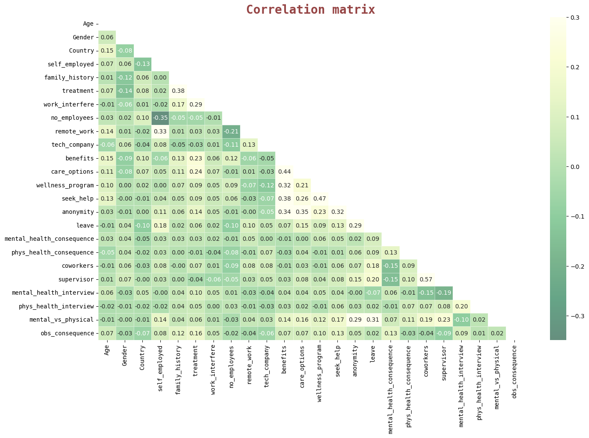



unfold_lessHide code

In [22]:

from wordcloud import WordCloud, STOPWORDS, ImageColorGenerator

from PIL import Image

words = ''.join(data['comments'].dropna())

plt.figure(figsize=(14,14), dpi=150)

wordcloud = WordCloud(max_words=200,

stopwords = STOPWORDS,

background_color = "white",

mask = np.array(Image.open("/kaggle/input/d/toomuchsauce/imagebrain/Untitled design.png")),

contour_color='#023075',

contour_width=1,

width=1500, height=800).generate(words)

plt.imshow(wordcloud, interpolation="bilinear")

plt.axis("off")

plt.show()

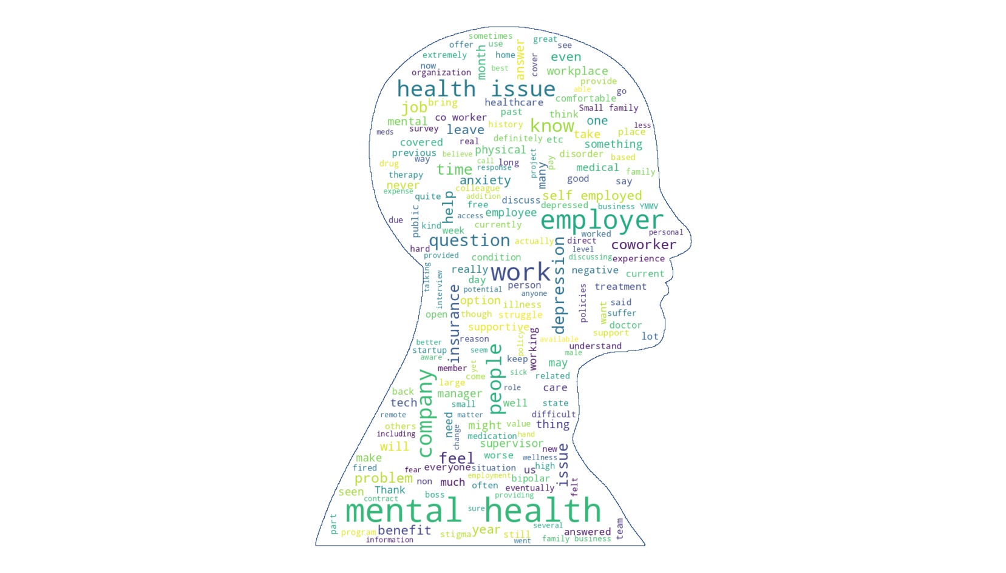

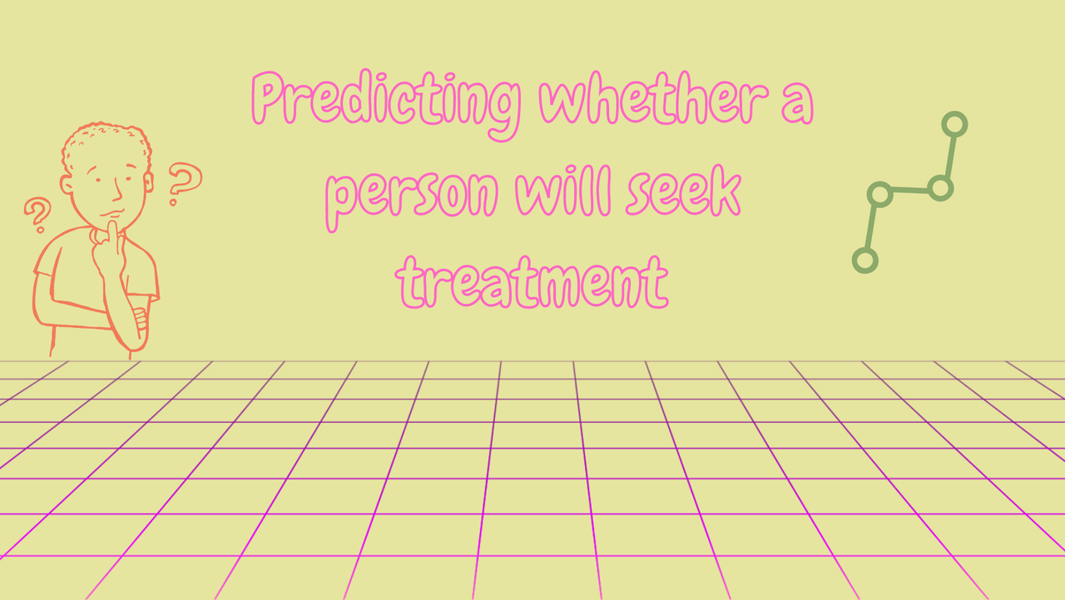

In [23]:

*# Encoding Target*

df.treatment = df.treatment.astype('category')

df.treatment = df.treatment.cat.codes

df.treatment.value_counts()

*# Train and Test set*

X = df.drop('treatment', axis =1)

y = df.treatment

cols = X.columns

encoder = LabelEncoder()

for col **in** cols:

encoder.fit(X[col])

X[col] = encoder.transform(X[col])

*# Splitting*

X_train, X_test, y_train, y_test = train_test_split(X, y, test_size = 0.2, random_state = 39)

unfold_lessHide code

In [24]:

from warnings import filterwarnings

filterwarnings("ignore")

steps = [('scaler', StandardScaler()),

('log_reg', LogisticRegression())]

pipeline = Pipeline(steps)

parameters = dict(log_reg__solver = ['newton-cg', 'lbfgs', 'liblinear'],

log_reg__penalty = ['l2'],

log_reg__C = [100, 10, 1.0, 0.1, 0.01])

cv = GridSearchCV(pipeline,

param_grid = parameters,

cv = 5,

scoring = 'accuracy',

n_jobs = -1,

error_score = 0.0)

cv.fit(X_train, y_train)

y_pred = cv.predict(X_test)

log_accuracy = accuracy_score(y_pred, y_test) * 100

print('**\033**[1m' +'Best parameters : '+ '**\033**[0m', cv.best_params_)

print('**\033**[1m' +'Accuracy : **{:.2f}**%'.format(log_accuracy) + '**\033**[0m')

print('**\033**[1m' +'Classification report : '+ '**\033**[0m**\n**', classification_report(y_test, y_pred))

cm = confusion_matrix(y_pred, y_test)

print('**\033**[1m' +'Confusion Matrix : '+ '**\033**[0m')

plt.figure(dpi=100)

sns.heatmap(cm, cmap = 'YlGn',annot = True, fmt='d')

plt.show()

**Best parameters :**  {'log_reg__C': 0.1, 'log_reg__penalty': 'l2', 'log_reg__solver': 'newton-cg'}

**Accuracy : 71.83%**

**Classification report :**

precision recall f1-score support

0 0.69 0.73 0.71 120

1 0.74 0.70 0.72 132

accuracy 0.72 252

macro avg 0.72 0.72 0.72 252

weighted avg 0.72 0.72 0.72 252

**Confusion Matrix :**

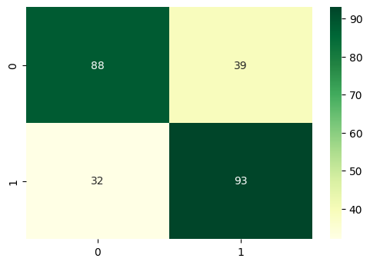

A simple model gave us an out of sample accuracy of about 70%.

* Thank You for sitting through the notebook
* Feel free to ask any questions